BLOCK DIGRAM:

Power Supply

Controller Unit

(Arduino)

LCD Display

Ignition Key

Motor Driver

Motor

GPS Module

Alarm

GSM Module

Flow Chart:

INITIALIZATION OF GPS MODULE

SERCHING FOR NETWORK

INITIALIZATION OF GSM MODULE

SERCHING FOR NETWORK

STOP RAILWAY & TURN ON BUZZER

TAKE LOCATION FROM GPS MODULE

SEND SMS ALERT WITH LOCATION TO USER

VEHICAL MOVING & CHECK FOR TRACK CRACK

IS CRACK DETECTED

NO

YES

Circuit Diagram:

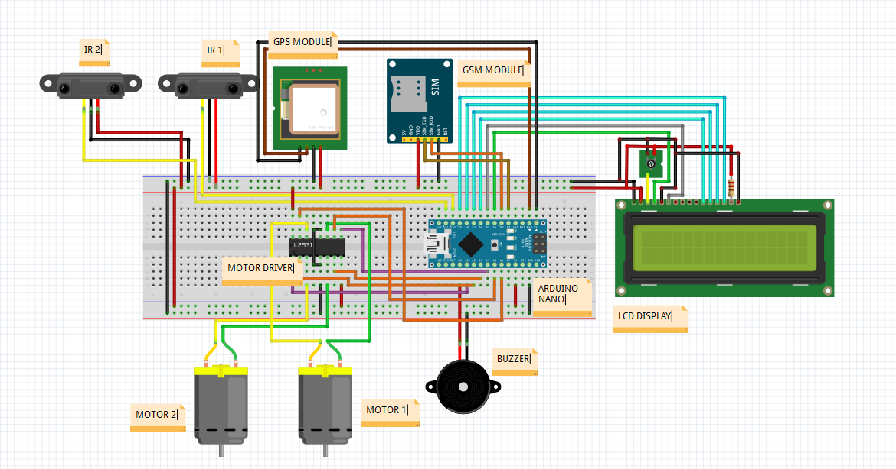

Algoritham :

1. Start
2. Initialization Of Gsm Module
3. Serching For Network
4. Initialization Of Gps Module
5. Serching For Network
6. Vehical Moving & Check For Track Crack
7. If Crack Detected Then, Stop Railway & Turn On Buzzer
8. Take Location From Gps Module
9. Send Sms Alert With Location To User
10. End

|  |  |  |  |  |  |
| --- | --- | --- | --- | --- | --- |
| **SR. NO.** | **COMPONENT** | **SPECIFICATION** | **UNIT PRIZE** | **QUANTITY** | **COST** |
| 1 | Arduino Uno | ATMEGA328P | 350 | 1 | 350 |
| 2 | GPS Module | SIM28ML | 475 | 1 | 475 |
| 3 | GSM Module | SIM800L | 550 | 1 | 550 |
| 4 | IR SENSOR | - | 50 | 2 | 100 |
| 5 | Battery | Lead acid | 100 | 3 | 300 |
| 6 | Transformer | Step down (12-0-12) | 120 | 1 | 120 |
| 7 | DC Motor | Voltage: DC 3V-6V  Current: 100mA-120mA | 170 | 2 | 340 |
| 8 | Motor Driver | L293D | 45 | 1 | 45 |
| 9 | Voltage Regulator | 7812/7805 | 10 | 2 | 20 |
| 10 | Capacitor | 1000uF/25v | 3 | 1 | 3 |
| 11 | Resistors | 220Ω | 1 | 5 | 5 |
| 12 | Diode | 1N4007 | 3 | 5 | 15 |
| 13 | Switch | - | 10 | 1 | 10 |
| 14 | LED | 3.3V/20mA | 3 | 5 | 15 |
| 15 | Connector | - | 10 | 3 | 30 |
| 16 | Connecting Wires | Male To Male  Female To Male  Female To Female | 3  3  3 | 25  25  25 | 225 |
| 17 | Header Strips | Male/female | 10 | 2 | 20 |
| 18 | LCD | 16*2 | 150 | 1 | 150 |